ICP2021 Assignment1 part_1 report

Name: Christian Paul Domingo
Username: eeuc1c
Date prepared: 2 March 2012
clear all
clc
close all

%Part 1-1 Assignment_1

% Cell Array block
breads_n_prices = {'MewTwo Cake', 20.00; 'Charizard Cake', 25.00; 'Eevee Cake', 10.00;...
'potion Cake', 10.50; 'PokeBall Cupcake', 12.50 ;'Rare Stone Cupcakes',19.99;};
staff = {'Ash', 'Brock', 'Gary', 'Misty'};

% variable block
date_now = (datestr(now,0));
Company_name = 'Christian Cake Shop';

%product 1
p1 = ceil(rand*6);
p1_item = breads_n_prices{p1,1};
p1_quantity = ceil(rand*9);
p1_price = breads_n_prices{p1,2};
p1_total = p1_quantity*p1_price;

%product 2
p2 = ceil(rand*6);
p2_item = breads_n_prices{p2,1};
p2_quantity = ceil(rand*9);
p2_price = breads_n_prices{p2,2};
p2_total = p2_quantity*p2_price;

%product 3
p3 = ceil(rand*6);
p3_item = breads_n_prices{p3,1};
p3_quantity = ceil(rand*9);
p3_price = breads_n_prices{p3,2};
p3_total = p3_quantity*p3_price;

final_total = p1_total+p2_total+p3_total;
VAT = final_total*.20;
curr_staff = staff{randperm(4)};

% printing block
fprintf('+-------------------------------------------------------------+\n');
fprintf('|%60s |\n','');
fprintf('|%-30s %30s|\n', date_now, Company_name);%prints date and company
fprintf('|%60s |\n',''), fprintf('|%60s |\n','');
fprintf('|%30s (%1i) x %4.2f = £ %6.2f | \n', p1_item, p1_quantity, p1_price, p1_total );%prints product 1
fprintf('|%30s (%1i) x %4.2f = £ %6.2f | \n', p2_item, p2_quantity, p2_price, p2_total );
fprintf('|%30s (%1i) x %4.2f = £ %6.2f | \n', p3_item, p3_quantity, p3_price, p3_total );
fprintf('|%30s ------------------------- |\n','');
fprintf('|%30s £ %6.2f |\n','Total to pay',final_total);
fprintf('|%30s £ %4.2f |\n','VAT',VAT);
fprintf('|%60s |\n','');
fprintf('|Thank you!, you have been served by %-25s| \n', curr_staff);
fprintf('|%60s |\n','');
fprintf('+-------------------------------------------------------------+\n');

clear all
clc
close all

%Part 1-2 Assignment_1

x1 = [-5 -2 -3 -1 0 0];
x2 = [ 5 2 3 1 0 0];

y1 = [0 1 3 2 5 0];
y2 = [0 -1 -3 -2 -5 0];

%upper left
fill(x1,y1,'k','edgecolor','k',...
'linewidth',1);
hold on
%upper right
fill(x2,y1,[rand,rand,rand],'edgecolor','k',...
'linewidth',1);
hold on

%lower right
fill(x2,y2,'w','edgecolor','k',...
'linewidth',1);
hold on
%lower left
fill(x1,y2,[rand,rand,rand],'edgecolor','k',...
'linewidth',1);
hold on
axis off

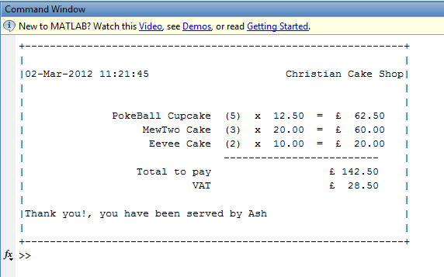
Assignment part 1-1 output 1

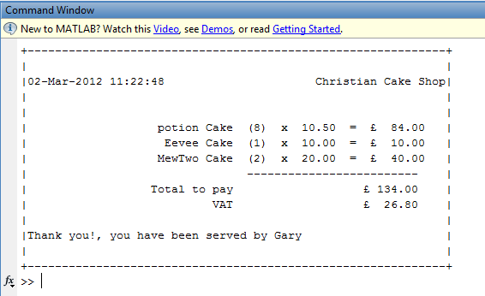
Assignment part 1-1 output 2

Assignment 1 part1 – 2 output 1

Assignment 1 part 1-2 output 2


---- Put additional comments here ----

